Student Name:harish kasaram

Student ID: 21077964

7PAM2000-0901-2022 Applied Data Science

Assessment 1

Table of Contents

Dataset Link 2

Visualization 1 2

Chart 2

Explanation 2

Visualization 2 3

Chart 3

Explanation 3

Visualization 3 4

Chart 4

Explanation 4

Reference 5

# Dataset Link

Dataset Link: - <https://fsadata.github.io/fsa-headcount/data/fsa-headcount-as-at-31-january-2018.csv>

Repository Link:- https://github.com/Kasaram1996/applied-data-science-assignment-1.git

Data Source Website: - <https://www.data.gov.uk/dataset/4914aa92-d251-4e87-97c3-53c39fabb405/fsa-headcount>

This dataset is downloaded from the official government data source portal. This data is of Food standard agency’s employee headcount which is organized by the gender or grade wise. The data which is taken from me that is of the one year and the year is March 2017- Feb 2018.

# Visualization 1

## Chart

On the basis of Instruction Produce the line plot with appropriate labels and a clear title in the first step, which is based on the dataset's various columns.

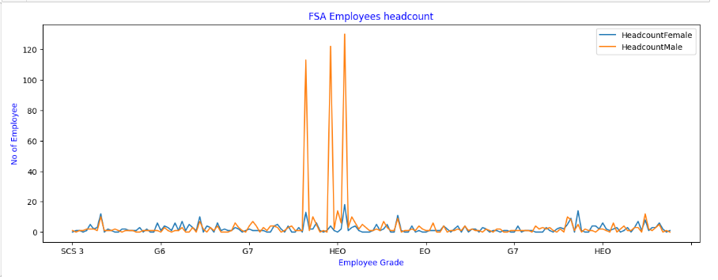

Screenshot 1

## Explanation

The above screenshot 1, The screenshot is the graph that is plotted using matplotlib and the type of the graph is line plot. In the above visual result, the dataset data plotted in the graph. The data in the dataset is the employee details of the Food Standard Agency’s employee which has multiple columns/types of the data. The data which I took for the plotting the result is the Total headcount which is counted by the code in the notebook and the result of the total headcount of employees grade-wise. In the data, there is the male and female column which is plotted in the graph and we can easily identify in the HEO grade the no of total headcount of the male and females is going high (Tweaks). So, we can say that in the HEO grade category the no of employees is big others are normal in the count.

# Visualization 2

## Chart

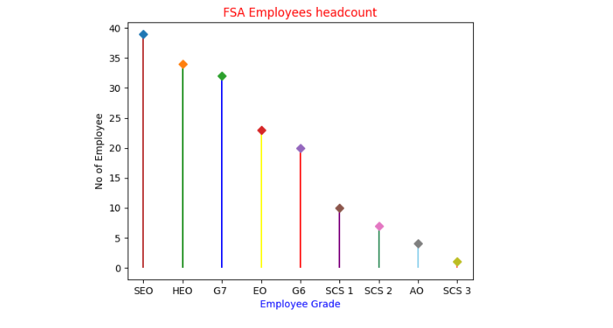

Screenshot 2

## Explanation

The graph was drawn using the Matplotlib library, as shown in screenshot 2 above and the type of the chart is Stem Plot it has the benefit of being able to plainly demonstrate the distributional shape of a data collection (web_page_person, 2022). That’s why I choose this to plot the data of the employee which is grade wise and the observation is much clearly shown in the chart. The highest no of employee which included female and male employees is clearly shown in the SEO grade and the lowest no of the employee grade is SCS 3. Which has only (0-5) employees.

# Visualization 3

## Chart

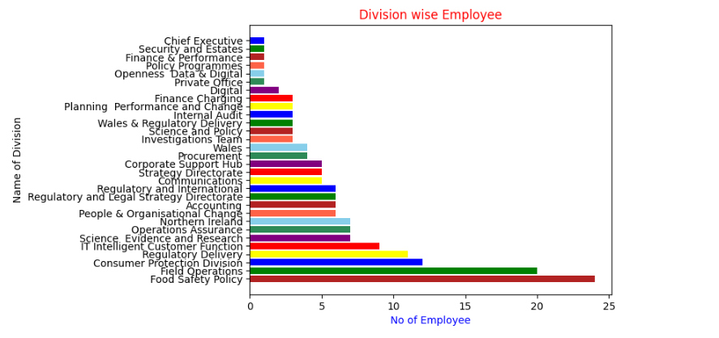

Figure 3

## Explanation

The graph was created using the Matplotlib library, as shown in screenshot 2 above and the bar graph is the type of the graph. This graph is looks very nice and attractive in view and understandable because this is plotted using the employee’s working Division wise means the employees who is working in the organization which Division they belong to. With the graph anyone can simply understand the no of employees in the different divisions is shown in the graph. The no of total employee including (male or female) is high in the number working in the division of “Food Safety Policy” and the low no of employee is working in the “Chief Executive” division. This graph is clearly giving the understanding of the working employee.

# Reference

Tweaks, E. (n.d.) How to plot multiple lines with python, Seaborn, Pandas and matplotlib? EasyTweaks.com. [Online] [Accessed on November 9, 2022]https://www.easytweaks.com/python-plot-multiple-lines-matplotlib-seaborn/.

web_page_person, T. K. (2022) How to draw stem plot using matplotlib? TutorialKart. TutorialKart. [Online] [Accessed on November 9, 2022]https://www.tutorialkart.com/matplotlib-tutorial/matplotlib-pyplot-stem-plot/.